**AIM :Aim: Design a Programmable Digital Data Display system.**

**APPRATUS :Arduino, LED’s, variable resistance, wires, Breadboard, Push Button**

**Circuit Diagram.**

**CIRCUIT DIAGRAM:**

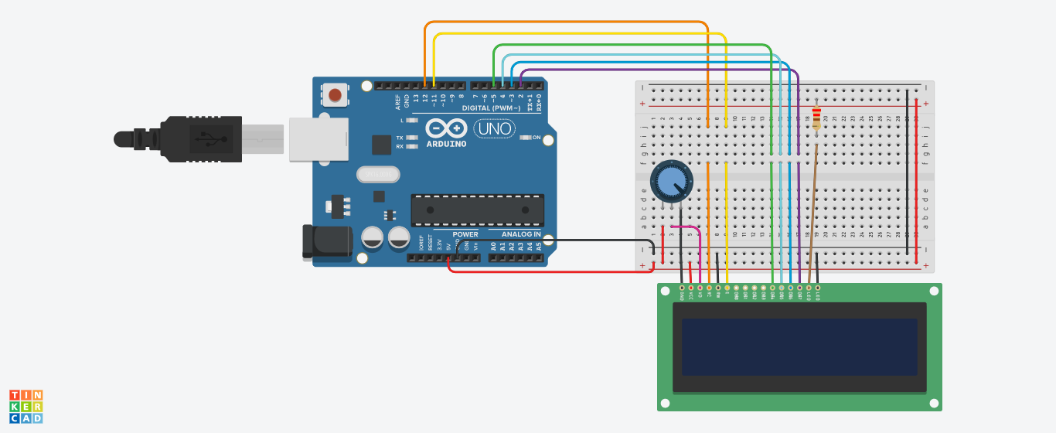

**THEORY** : A **liquid-crystal display** (**LCD**) is a [flat-panel display](https://en.wikipedia.org/wiki/Flat_panel_display) or other [electronically modulated optical device](https://en.wikipedia.org/wiki/Electro-optic_modulator) that uses the light-modulating properties of [liquid crystals](https://en.wikipedia.org/wiki/Liquid_crystal). Liquid crystals do not emit light directly, instead using a [backlight](https://en.wikipedia.org/wiki/Backlight) or [reflector](https://en.wikipedia.org/wiki/Reflector_(photography)) to produce images in color or [monochrome](https://en.wikipedia.org/wiki/Monochrome).[[1]](https://en.wikipedia.org/wiki/Liquid-crystal_display#cite_note-1)

**LERNING &OBSERVATION :**

1. Use of LCDand its functioning.
2. To connect LCD with arduino.
3. Always in circuit ground should always have least resistance.
4. Coding of LCR and its library function.

**PROBLEM & TROUBLESHOOTING:**

1. Mistake in coding in statement.
2. Logical mistake happened in connection.

**LEARNING OUTCOMES**:

1. Use of ground and resistance in circuit.
2. How to connect LCR in circuit.
3. Resistance must be of 10 kilo ohm not less than that.
4. To work on both analog and digital pins.